**CURRENCY CONVERTER:**

The Currency Converter is a simple program designed to convert an amount from one currency to another using fixed exchange rates. The program allows the user to enter an amount in the source currency, select the desired target currency, and then calculates the equivalent value. It provides an easy way to understand the concept of exchange rate calculations and basic program flow. The project includes features such as input validation, performing conversions based on the current exchange rate of the present day, displaying the converted result, and an option to exit the application.

**PROCEDURE:**

1. **Start the program**
   * Initialize the currency converter by creating an object of the “CurrencyConverter” class.
   * Prepare the scanner to read user input.
2. **Display available currencies**
   1. Manually print the list of currencies with their corresponding numbers.
   2. Helps the user know which option to choose for conversion.
3. **Select source currency**
   1. Prompt the user to choose the currency they want to convert from.
   2. Validate input to ensure it is within the allowed range, otherwise ask again.
4. **Select target currency**
   1. Prompt the user to choose the currency they want to convert to.
   2. Validate input to ensure it is within the allowed range, otherwise ask again.
5. **Enter exchange rate**
   1. Ask the user for the exchange rate between the selected source and target currencies.
   2. This allows flexible conversion based on current or custom rates.
6. **Enter amount to convert**
   1. Prompt the user to input the amount in the source currency.
   2. This is the value that will be multiplied by the exchange rate.
7. **Perform conversion**
   1. Multiply the entered amount by the exchange rate to get the converted amount.
   2. Display the result showing both source and target currency values.
8. **Ask to continue**
   1. Ask the user if they want to perform another conversion.
   2. Validate the response to accept only “yes” or “no” and repeat or exit accordingly.
9. **End program**
   1. If the user chooses “no,” terminate the loop.
   2. Display a thank-you message and end the program.

**CODE:**

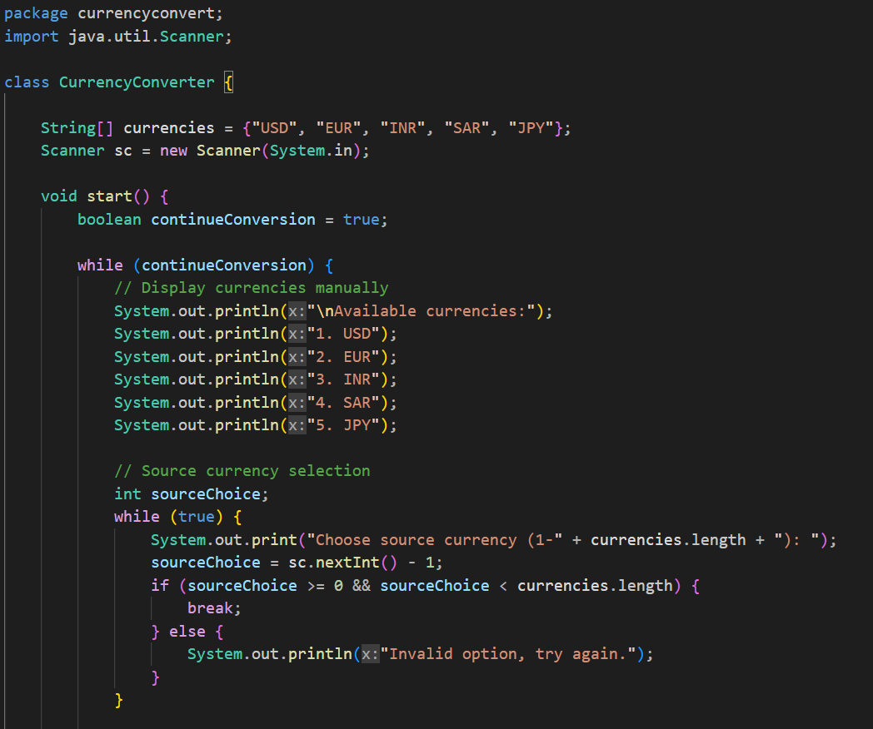

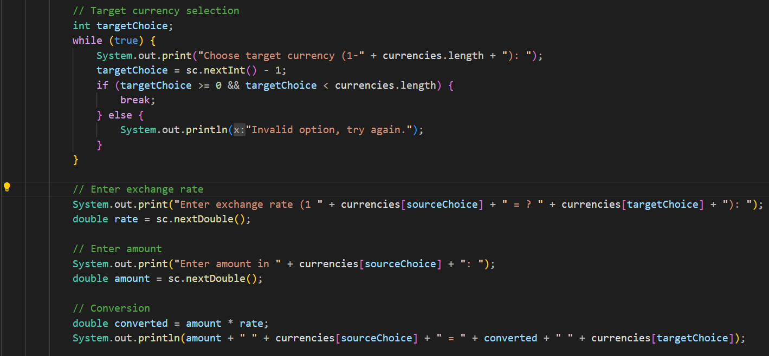

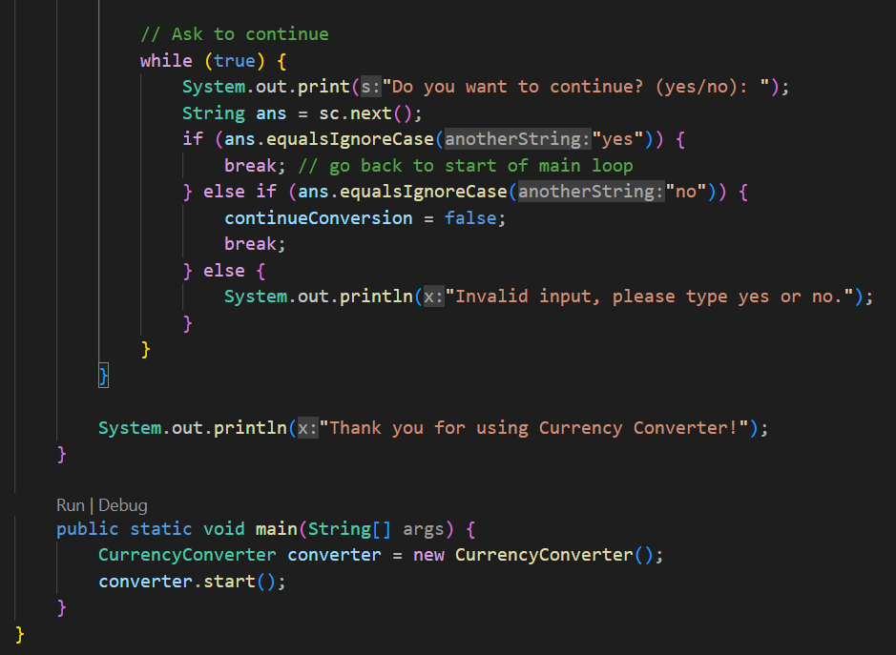

**OUTPUT:**

